**LAB PRACTICE 3**

**K.SAI KUMAR** (192110215)

1.Develop a system using UML for implementing E-Ticketing System. This is to be used by the passenger for reserving the tickets for their travel. This E-ticketing is organized by the central system. The information is provided by the railway reservation system.

**USE CASE DIAGRAM :**

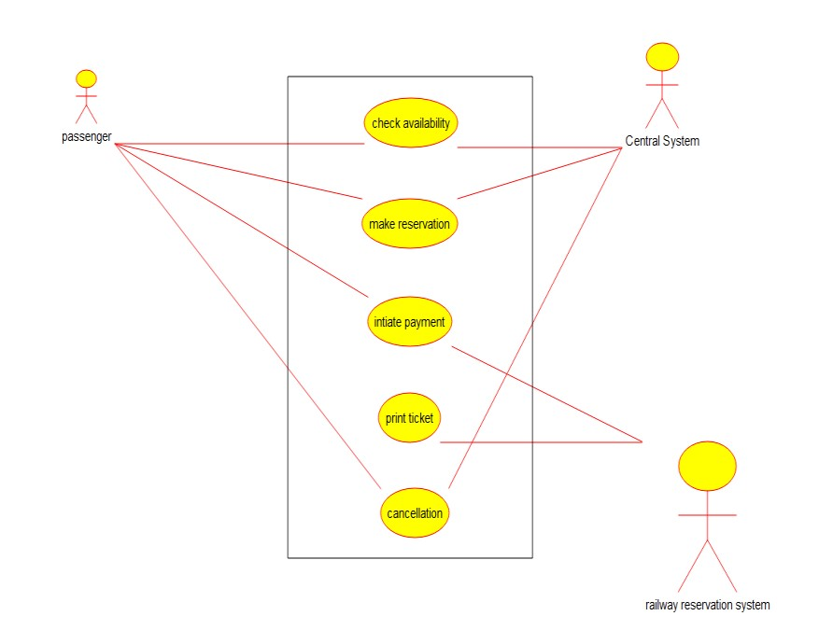

**CLASS DIAGRAM :**

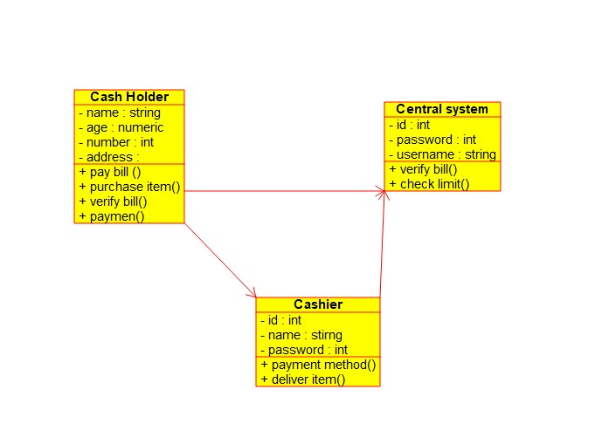

**ACTIVITY DIAGRAM :**

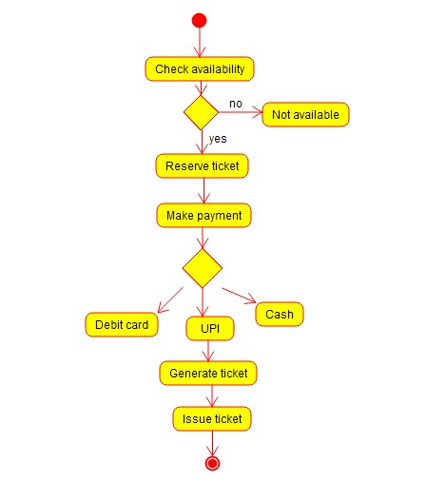

2.Develop a system using UML for implementing Credit Card Processing System. In this system, the cardholder can purchase items and pays the bill with the aid of a credit card. The cashier should accept the card and proceed with the transaction using the central system. The bill is to be verified and the items are delivered to the cardholder based on it.

**USE CASE DIAGRAM :**

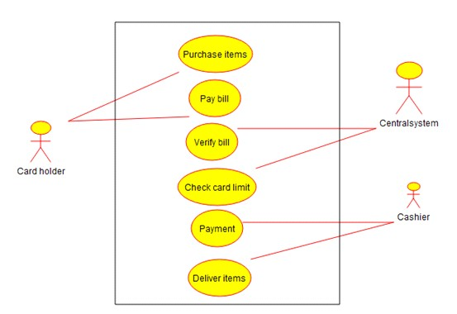

**CLASS DIAGRAM :**

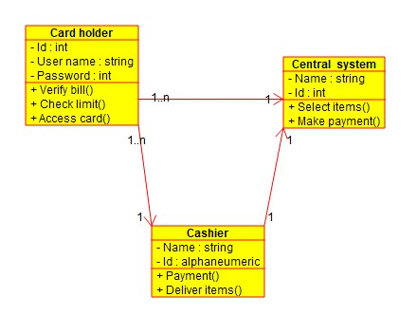

**ACTIVITY DIAGRAM :**

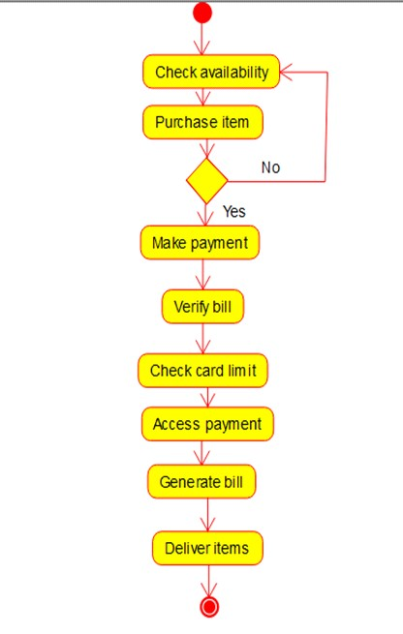

3.Develop a system using UML for Software Personnel Management System. It should be used to process the details of a person who works in a software company. The details are to be stored in the central management system for cross-checking the person’s details.

**USE CASE DIAGRAM :**

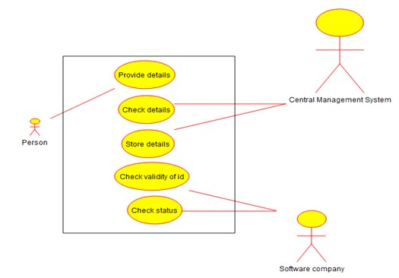

# CLASS DIAGRAM :

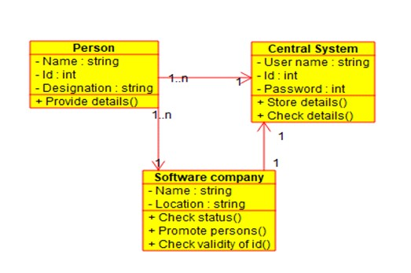

**ACTIVITY DIAGRAM :**

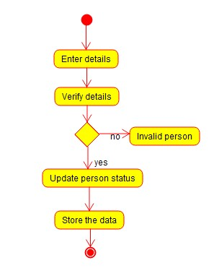

4.Develop a system using UML for E-Book Management System. It should be designed to manage the books that were read through the internet. That should consist of the details of the e-book that were read by the user online. It will be controlled by the central system. This system should act as a backup of all details together.

**USE CASE DIAGRAM :**

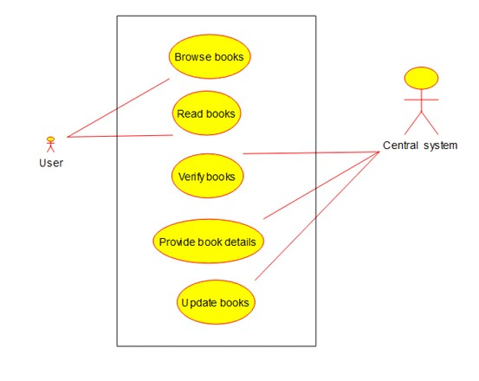

**CLASS DIAGRAM :**

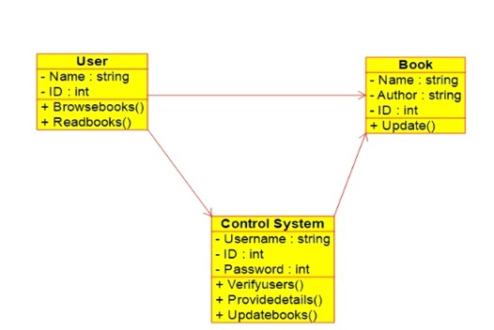

**ACTIVITY DIAGRAM :**

